

**SPARTA**

*SPORTS FOR ALL, A BOT FOR SPORTS*



**TABLE OF CONTENTS**

The Introduction

The Problem Statement

Proposed Solution

The Flowchart

Working

Constraints and Limitations

Prospects

Conclusion

**THE SPARTANS**

ADITI SAINI

JANNAT BEDI

DEBASHREE ADDI

MAYANK NARIANI

RAKSHITHA ARUN



**THE PROBLEM**

The University hosts a multitude of sports and recreational facilities that provide a galore of opportunities for students to mingle and develop skills at the same time. However, the problem lies in the lack of connectivity between players possessing similar interest in sports.

No system has been established so far that makes it possible for people to know each others’ interest in sports, specifically. There is neither a predefined method to find out about those who can spare time to unwind, at a given moment.

In this lies the premise of our project.

There is an immense capability of uniting people across nationalities, ages, genders and academic disciplines in the spirit of sportsmanship that lies undiscovered and can be solved by the employment of networking.

**THE BACKGROUND**

On a lazy Sunday morning or when the day has been tiring,

A football field or perhaps a TT table is a student’s beckoning.

With its general appeal as a favourite pastime, coupled with the adrenaline rush and health benefits its brings along, sports gives us a perfect time to bond with friends.

Most often, students tend to form teams within their friends circles. At University, the element of variance in timetables from student to student reduces the possibility of friends finding time slots that conform to all the parties involved. This consequently disrupts the plan.

Secondly, there is the case of varying interests in sports. The disinterest of a student in a particular sport can potentially dissuade another’s decision to play it due to lack of availability of players. But the very same situation might be faced by other people on campus, that neither sides are aware of.



**THE PROPOSED SOLUTION**

The abundance of resources that facilitate sports as well as the urge to ensure efficiency in terms of time management are parallel aims of the bot. The main purpose lies in capturing the similar interests of people of diverse nature and uniting them through technology.

Our bot, SPARTA, has been designed with university students in mind. It intends to capture information about people playing a sport or planning to play a sport and treats it as an event; thereby making it possible for more people to join the existing players.

SPARTA, is location and sport specific, which means that it’s database identifies a list of locations at NTU, specifically curated by the designers as well as a list of most commonly played sports.

The user is able to access the database once they provide SPARTA their basic information which would include name and matric number. It is the user’s discretion about deciding whether to create a new team or join an existing one(subject to vacancy).



**FLOW OF CODE**

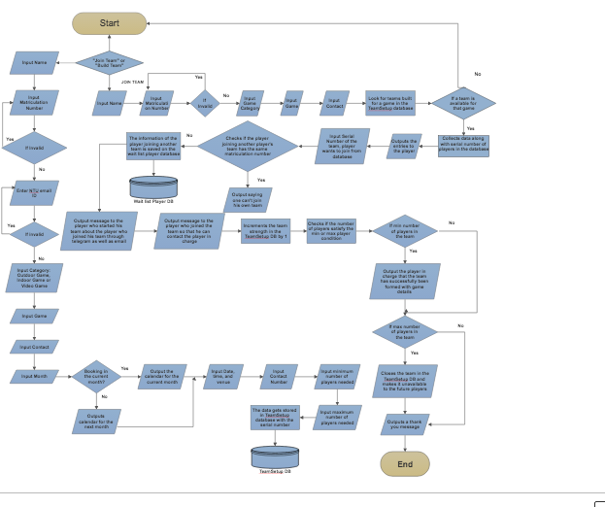

For more clarity visit this link: <https://cloud.smartdraw.com/share.aspx/?pubDocShare=E561193598B6484E2F793D284589606D29D>

**TESTING THE BOT (WITH SCREENSHOTS)**



Once, the user presses /start, Sparta, the bot, greets the user and asks if the user wants to join or build his team. It makes use of custom keyboard to provide a user- friendly experience. It then goes on to take necessary information from the user which is then stored in the corresponding databases. The TeamSetup database contains information about the team leaders who are looking for players to join their team while the Waitlist player database, contains information about the players joining team leaders. Here is a snapshot of the sqlite:

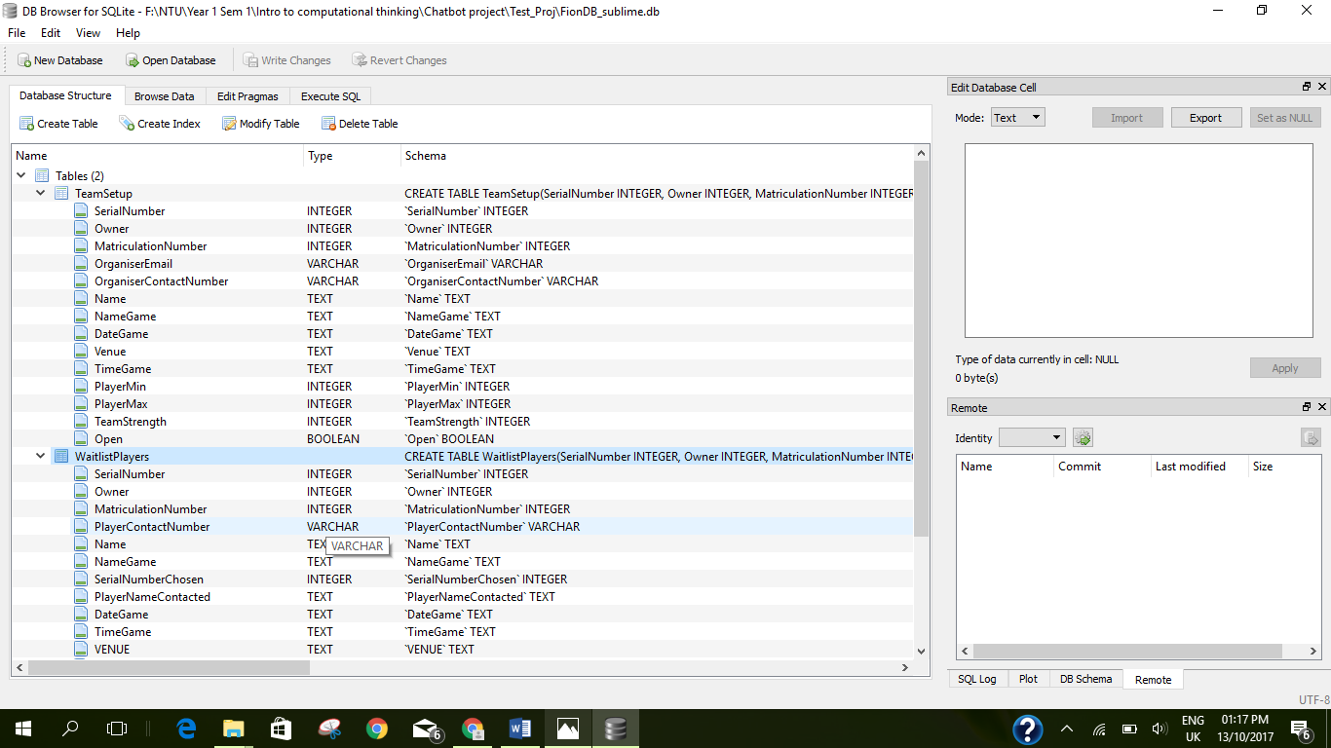

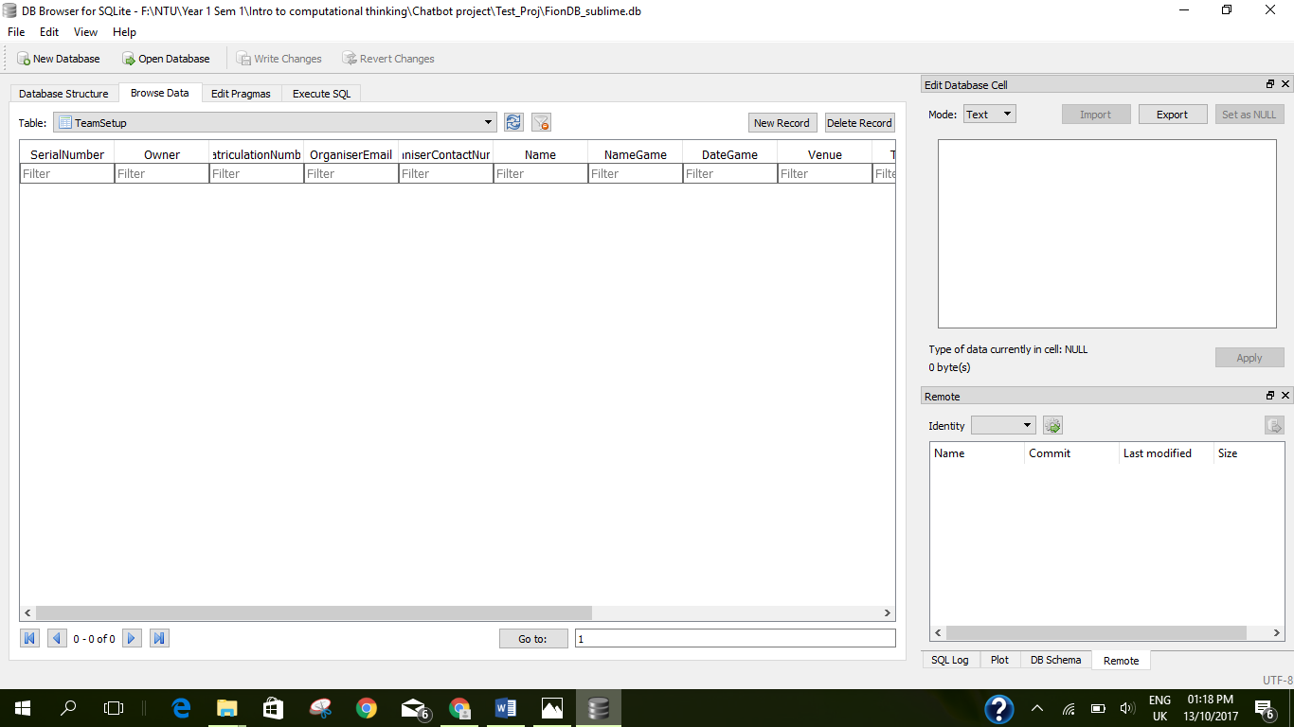

As records are added, they get stored in the database for easy accessibility.

 

By importing emojize, emojies are made visible in the messages. Calendar and datetime libraries enabled us to obtain the present date and time with calendar as the output. Also, the user who has built his team will be updated via telegram as well as gmail as players start to join his team.

The best feature is that as minimum number of players are satisfied for the team, the team leader gets a notification on telegram saying his team is ready and provides updates about the event.

Also if the team fulfils the condition of maximum number of players, it would not be available for other future players to join the team. This is done by the OPEN record in the TeamSetup database that turns on if the team is still open for players and off if the maximum number of players condition is fulfilled. Hence, the bot makes use of logical deletion to make this feature available.

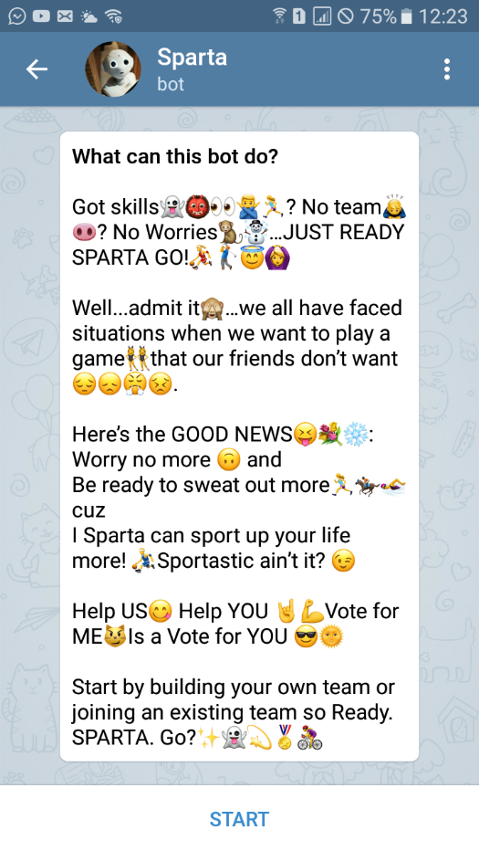 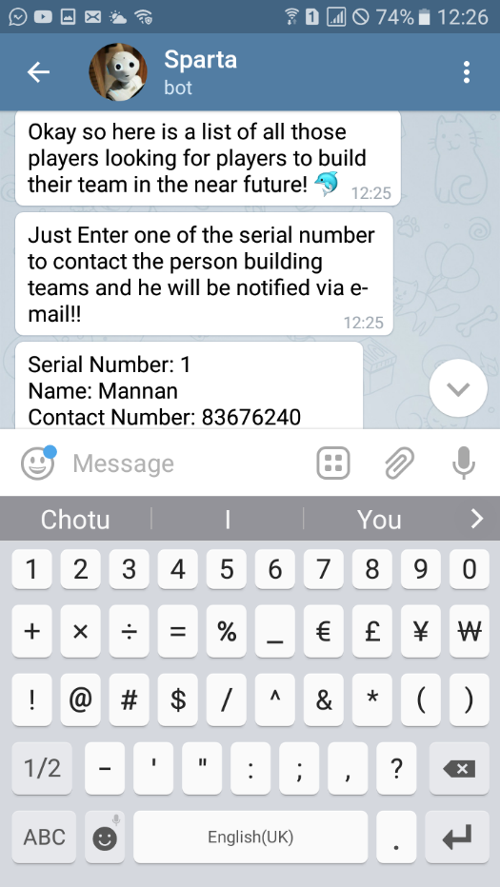 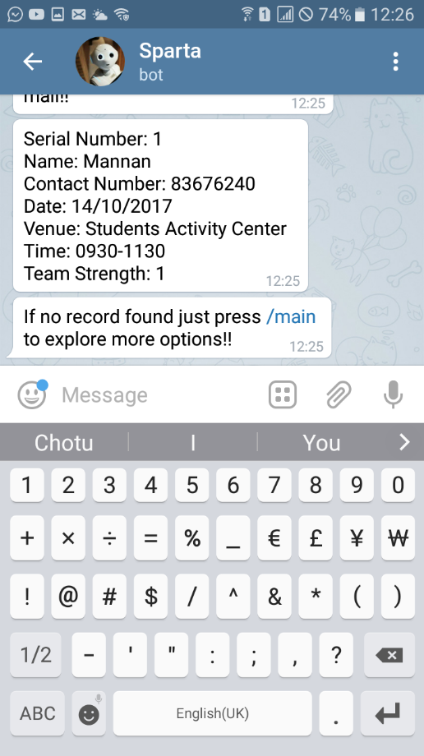

These are the screenshots of the user who is trying to join an existing team. The first screenshot is the set description of the bot that publicises SPARTA through the slogan: Ready Sparta Go. The user then goes on to input his details which is then stored in the WaitlistPlayers database. Depending on the category of game chosen by the player, all the records in the TeamSetup database, with that game in the categories, is made visible to the user. The user then goes on to choose the serial number of the team he wants to join.

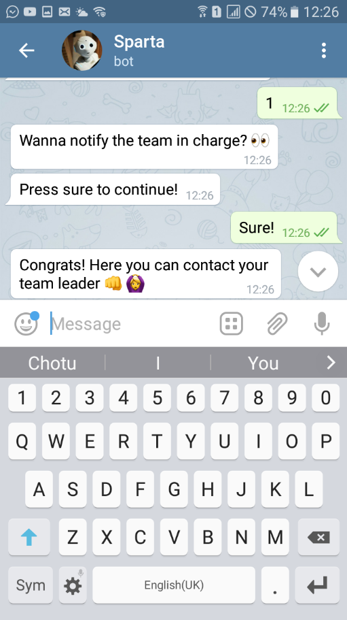 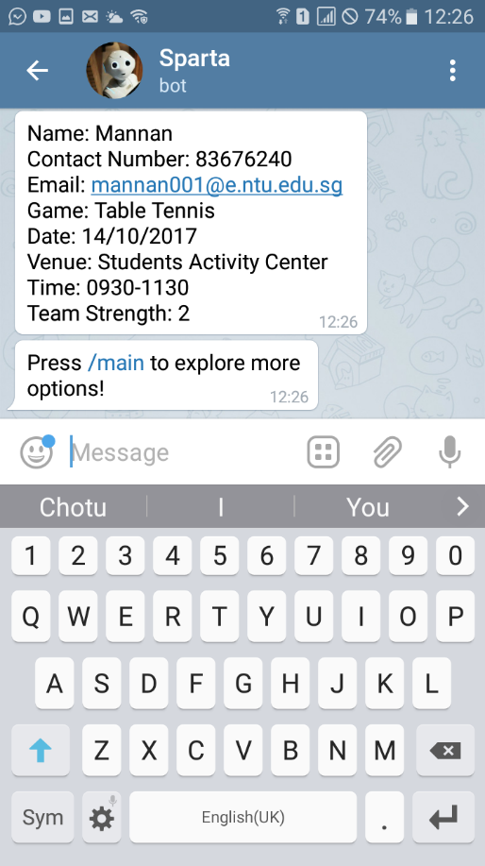

As soon as he presses the serial number, the contact details of the team leader is provided to him.

What’s cooler is that another message is sent to the team leader via telegram stating the details of the player who has joined his team.

As this process occurs, the team strength is updated in the TeamSetup database and a check is made to keep track if the number of players in the team are in between the range of maximum and minimum stated by the team leader.

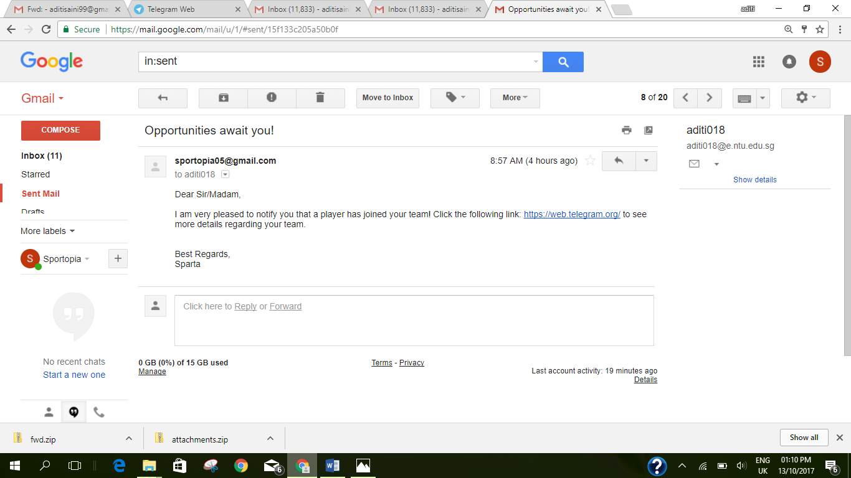

Here is where web service integration comes in. Gmail has been integrated in a way that on logging in, the team leader gets a notification that a player has joined his team and congratulates him for using SPARTA.

Hence, in this way, SPARTA, the sport bot, attempts to connect people and promote togetherness

**For more information: Here is the link of our bot:**

[t.me/Spartaaa_bot](tg://resolve?domain=Spartaaa_bot) .

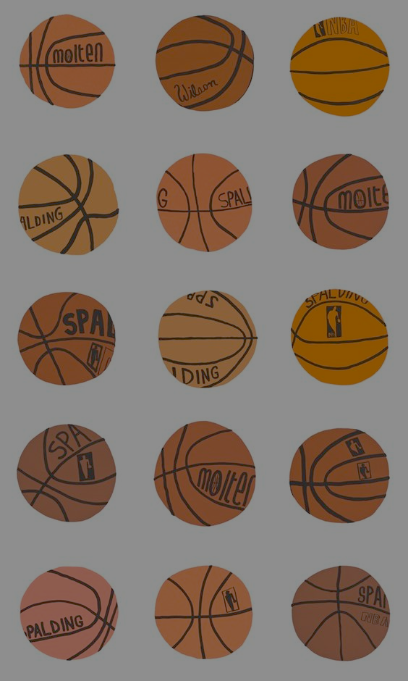

**LIMITATIONS**

Sparta is still a baby in terms of its development and there are a few features that we would’ve loved to pack it with given, we could work on our coding to make it sophisticated and had there been more time. Below, is a list of observations we’ve made in terms of scope for improvement.

Sparta expects the user to enter all the personal particulars, every time it is accessed. It doesn’t use the bot id to reference the user but rather the information keyed in by them. This makes the initial login process cumbersome for the user. An apparent and ideal solution to this would be to function using the bot id.

However, the reason we have used the personal information in preference to the former is that, this would facilitate multiple players to be able to use a single device to login, hence increasing user friendliness in a way.

Our version of Sparta raises a concern about the security of information that the users key in. There is no guarantee about the safety of the details we provide the bot during our login and the sensitivity of the information demands that we develop a system that’ll make no compromise in this matter.

There is one element that hasn’t been included now but would greatly contribute towards the practicality of our bot if done. Although the players make a choice of the venue and time slot of their game, there is a possibility that there are people who aren’t using the bot facility, planning to occupy the venue at the same time. This can neither be predicted nor solved unless there’s a realtime watch on the venue that updates Sparta.

The practical technicalities aside, we feel that a more interactive interface could engage and interest the user more than the existing one.



**THE FUTURE**

The very fact that Sparta leaves us immense opportunity to further expand on its capabilities, speaks of the endless possibilities that python, coupled with human creativity, boasts of. We’ve put a little thought into what more Sparta can grow into, with more effort and in the course of time. These ideas stem primarily from the limitations that we noticed in Sparta, thus translating the minute setbacks into prospective growth.

As discussed earlier, the bot could source information about the occupancy and vacancy of a venue by the means of a crowd watch system, similar to that already present in the NTU website. This not only increases the practicality of the bot, but also bridges the gap between those who use the app to make plans and those who don’t.

Creating groups to train for a sport wherein there’s a tutor who hosts practice sessions to help those in need of help with a sport,could add more value to the bot.

Another interesting aspect that could find application in our bot would be the concept of weather forecast. The bot can help assess whether the weather is suitable to play an outdoor game the player has picked at the particular timeslot, else it could suggest an alternatively suitable option that wouldn’t encounter weather problems.

The next idea is a little more elaborate and includes the element of time management. The bot could access the particular student's timetable through STARS planner and suggest time slots wherein the student can afford a break to unwind with sports.

Sparta could also be officially available on the NTU website, much like the library time slot booking facility, as it’s relevant to students and teachers who want to play sports, alike.

Expanding this facility into a residential neighbourhood could help Sparta gain popularity among people off-campus, slowly setting the atmosphere for further geographic expansion.



**THE CONCLUSION**

In conclusion, our bot provides a platform to bring people together on the basis of their common interest in a particular sport at a particular date and time. Sparta not only satisfies the need of a user to play a specific sport, but is also a means to meet new people and make more friends. Sparta, in its approach, is quite flexible: It’s up to the user to decide whether they are interested in joining a team or building their own , and also decide the date ,time and venue that suits them the best.

Sparta doesn’t stop here, it notifies one when the requirement of minimum number of team players for a particular sport is met, and removes the team from the available choices for the next user once the number of team players reaches its maximum level. In its own way, Sparta encourages people to take up sports in their available time and interact with new people in the process.

But as they say, perfection is just an illusion, our bot has some flaws too. Its cumbersome login process wherein the user must fill their details every time they want try a different sport or a different time,prove to be a bit of a setback for Sparta. But its huge advantages overshadow its limitations.

What makes Sparta dear to us is the fact that we’ve bonded over it as a team and enjoyed the process thoroughly despite our moments of panic and occasional state of cluelessness. At this juncture, we would like to thank Professor Lua Rui Ping for creating an environment conducive for us to explore a real life application of python and also for his continuous support and valuable inputs through the course of it. Considering the large scope in this field, we feel that if we continue working on Sparta, we can make it better. After all, there is a crack in everything. That’s how the light gets in!